Equatorial Guinea

## Freedom House political status

The data set shows the Freedom House political scores and status of the country each year.

## # A tibble: 19 x 5  
## country iso3c date mean status   
## <chr> <chr> <dbl> <dbl> <chr>   
## 1 Equatorial Guinea GNQ 1996 7 Not Free  
## 2 Equatorial Guinea GNQ 1998 7 Not Free  
## 3 Equatorial Guinea GNQ 2000 7 Not Free  
## 4 Equatorial Guinea GNQ 2002 6.5 Not Free  
## 5 Equatorial Guinea GNQ 2003 6.5 Not Free  
## 6 Equatorial Guinea GNQ 2004 6.5 Not Free  
## 7 Equatorial Guinea GNQ 2005 6.5 Not Free  
## 8 Equatorial Guinea GNQ 2006 6.5 Not Free  
## 9 Equatorial Guinea GNQ 2007 6.5 Not Free  
## 10 Equatorial Guinea GNQ 2008 7 Not Free  
## 11 Equatorial Guinea GNQ 2009 7 Not Free  
## 12 Equatorial Guinea GNQ 2010 7 Not Free  
## 13 Equatorial Guinea GNQ 2011 7 Not Free  
## 14 Equatorial Guinea GNQ 2012 7 Not Free  
## 15 Equatorial Guinea GNQ 2013 7 Not Free  
## 16 Equatorial Guinea GNQ 2014 7 Not Free  
## 17 Equatorial Guinea GNQ 2015 7 Not Free  
## 18 Equatorial Guinea GNQ 2016 7 Not Free  
## 19 Equatorial Guinea GNQ 2017 7 Not Free

## Freedom House classification of political change

The data set shows the GDP growth and the ecomic growth classification of the country each year.

## # A tibble: 19 x 4  
## country iso3c date politicalChangeFH  
## <chr> <chr> <dbl> <chr>   
## 1 Equatorial Guinea GNQ 1996 no change   
## 2 Equatorial Guinea GNQ 1998 no change   
## 3 Equatorial Guinea GNQ 2000 no change   
## 4 Equatorial Guinea GNQ 2002 autocratization   
## 5 Equatorial Guinea GNQ 2003 no change   
## 6 Equatorial Guinea GNQ 2004 no change   
## 7 Equatorial Guinea GNQ 2005 no change   
## 8 Equatorial Guinea GNQ 2006 no change   
## 9 Equatorial Guinea GNQ 2007 no change   
## 10 Equatorial Guinea GNQ 2008 autocratization   
## 11 Equatorial Guinea GNQ 2009 no change   
## 12 Equatorial Guinea GNQ 2010 no change   
## 13 Equatorial Guinea GNQ 2011 no change   
## 14 Equatorial Guinea GNQ 2012 no change   
## 15 Equatorial Guinea GNQ 2013 no change   
## 16 Equatorial Guinea GNQ 2014 no change   
## 17 Equatorial Guinea GNQ 2015 no change   
## 18 Equatorial Guinea GNQ 2016 no change   
## 19 Equatorial Guinea GNQ 2017 no change

## Freedom House score trend

The plot shows the Freedom House scores trend of the country.

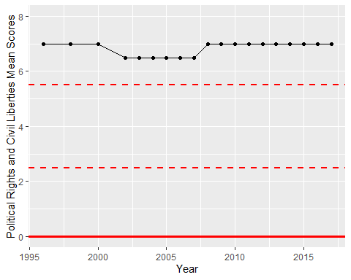

Freedom House Score Trend